Preface 2

Our Philosophy 3

Who we are 4

What we offer! 5

Section 1: Getting Started; Software Basics 6

Lesson 1: “Workspace basics or (101)” 7

Accessing your Sanrio Workspace 7

Logging On 8

Lesson 2: “Navigating your Workspace” 9

Application Layout (Your working parts!) 10

1) Your Logo 11

2) Modules: 12

3) Processes: 12

4) Work Area: 13

5) Tabs 13

6) Status Bar 14

7) Change Password 14

8) Logout 14

Section 2: Working With Data & Forms 15

Content Management/File Share 28

Simple Software Inc.

Preface

Welcome to our Simple Software courseware! This manual is intended for people to learn about how the services we provide can assist any business deploy software that caters to your specific needs. Not only will we walk you through the basics of using Simple Software, we will train you to leverage our product in order to deploy a complete solution, tailored to your company.

Our Philosophy

Simple Software helps you create business solution software that will be affordable, easy to use, and help you get the job done without getting in the way.

The benefit of using Simple Software over other “software-as-a-service” products is simple. We have developed a multitenant solution that runs as smoothly as a single instance solution. The engine that runs your application keeps your data and applications isolated but you still gain the benefits of a shared framework.

Remember, when using this manual it’s important to keep the following in mind. From time cards and inventory management to point-of-sale and customer tracking, Simple Software can help your business streamline your products so that you have time to grow your company. As your company grows, your Simple Software solution grows with it because we make it easy for you to add, update and extend your application. There has been over the last several years a growth in the peoples interest for better technology. When designing Simple Software Services Inc. our dedicated designers designed our services with to make it easy for every user. This interest people have had in having the simplest product that provide the best quality services for each company. Our software has been in development and production since 1995 and is used by many clients with a wide range of requirements. We design our products to be flexible to your business needs and simple to learn.

Who we are

Simple Software Inc. Workspace Designer builds database and reporting applications for software-as-a-service cloud environments – without hand-coding. Our simple engine generates SaaS applications that are easy to customize and ready to deploy. We offer a web-based applications run on Linux servers, and we guarantee a 99.994% uptime with 24/7 access; as well as the highest possible security measures.

Check out some of the features Simple Software provides for your business or organizational needs:

[Manage Your Data](http://www.simpsf.com/site/3w/features/data/),

[Create and Manage Your Applications](http://www.simpsf.com/site/3w/features/application-editor/),

[Control Access to Information](http://www.simpsf.com/site/3w/features/security/),

[Create and Manage All of Your Files](http://www.simpsf.com/site/3w/features/file-manager/).

“Simple Software’s Workspace is made for their employee’s attention to be focused on business; not on how to use software.”

~Patrick Peterson, Simple Software, Inc.- Chief Operations Officer

Today’s applications often force you to conform to the software instead of the software integrating into the way you do things. Simple Software provides a database-driven platform for clients to create, manage, and use applications for all of their business needs.

What we offer!

Let’s take a quick look at the main services and tools Simple Software has to offer.

**• Your Database Software**

Build applications from scratch or start with a template from application gallery. You control permissions and can administer applications from anywhere, at any time.

**• Generate Applications**

Create your data store and a custom data application will be generated that you can begin using immediately or tailor it to your needs through configuration and customizations.

**• Relate Data**

Data stored in Simple Software applications can be related, with context, to data in any other Simple application. These loose, two-way, contextual relationships turn your data into information that you can report, graph, chart or otherwise display or manage.

**• Integration Layer**

Enable two-way data integration with Simple Software applications using our web service API.

“It’s like your own IT department!”

~Christopher Robison, Simple Software, Inc.- Chief Executive Officer

Section 1: Getting Started; Software Basics

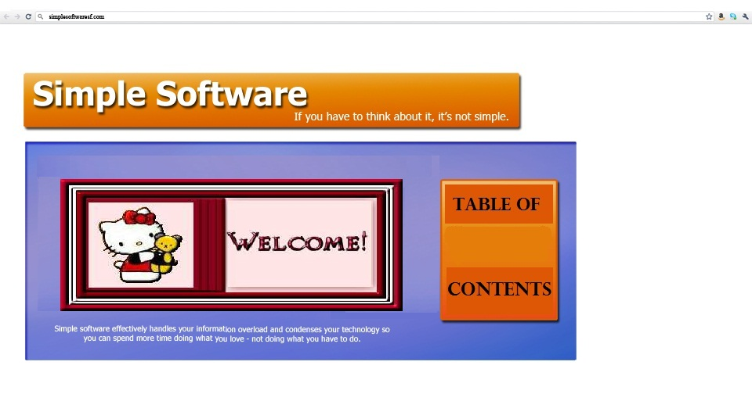

In this section you will learn the basic fundamentals of moving around in your workspace*.*

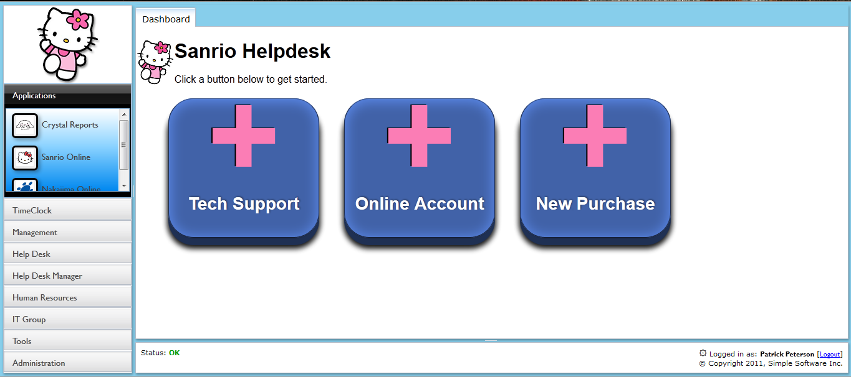

Lesson 1: “Workspace basics or (101)”

Accessing your Sanrio Workspace

Since your Sanrio Workspace resides online, you will access our software using most internet ready computer or mobile device. We suggest you download Firefox 5.0+ in order to enjoy the full experience.

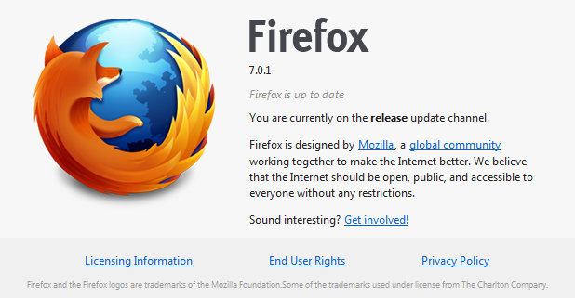

If your company does not have a workspace, you may create one from our homepage at:

<http://www.simpsf.com>

Simply click on ‘Free Trial’, complete the form, and an email will be sent with your new workspace internet address. We suggest you bookmark it!

Open your Internet browser and type your workspace address into the address bar.

<http://sanrio.simpsf.com>

Logging On

If you entered the correct address, you will see a login screen like this:

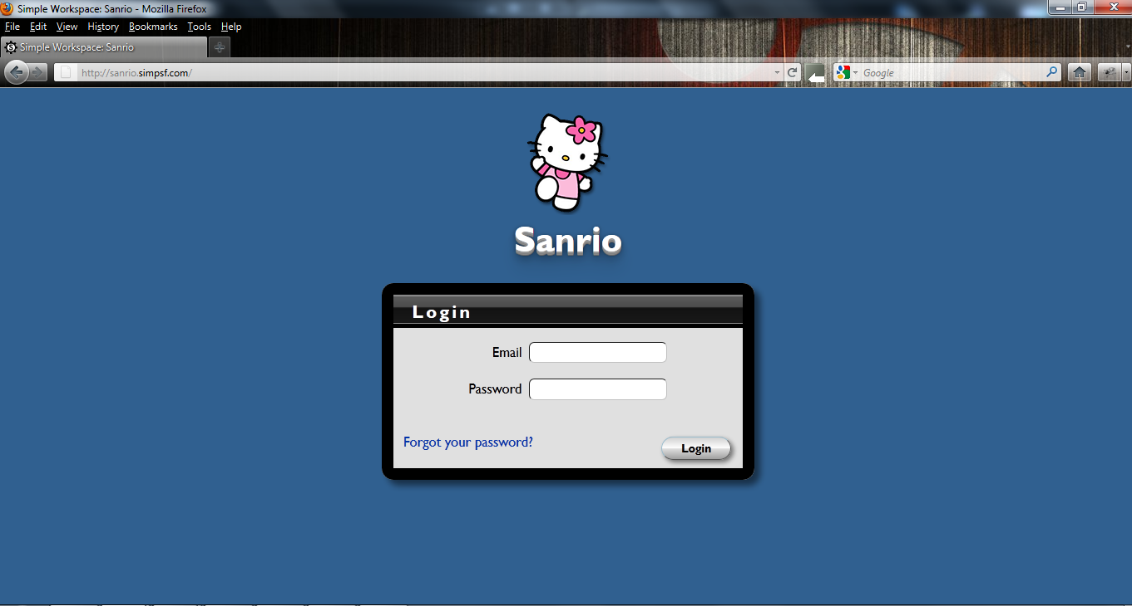

(There is a “Forgot your password?” link which will guide you through the necessary steps to retrieve your password.)

Login using your email address and password. For employees without an email address, login using your first initial + last name (John Doe would login as jdoe). Default passwords for Sanrio is your employee number located on your check stub.

Lesson 2: “Navigating your Workspace”

After logging in, you will see your company’s Simple Software Workspace.

The “Sanrio Helpdesk” dashboard contains shortcuts to various requests. Within the Helpdesk you can request:

* Tech Support
* Online Account
* New Purchase



Let’s take a moment to discuss the application “Workspace” layout…

Application Layout (Your working parts!)

There are many parts that make up your Workspace. Our goal is to design a flexible interface that looks familiar to anyone that has used email.

We will go over these in detail but here is a quick reference:

1. Your Logo
2. Modules
3. Processes
4. Work Area
5. Tabs
6. Status Bar
7. Change your password
8. Logout

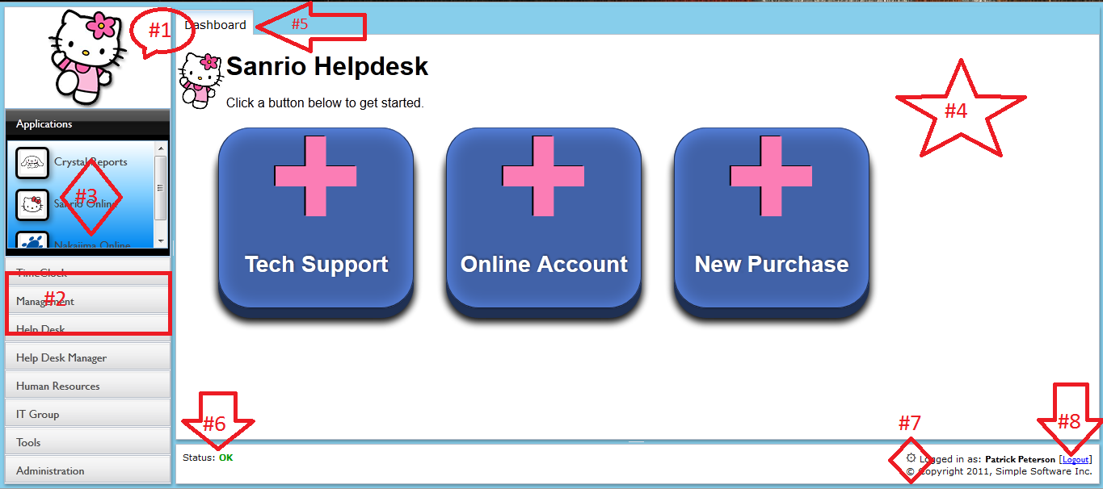

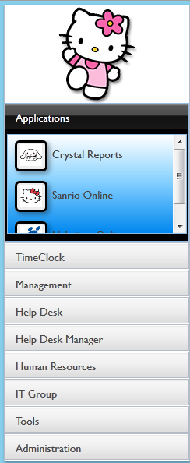

Sometimes referred to as “left navigation pane”

##### Your Logo



There are many ways of customizing your Workspace, and having your logo displayed is just one of them. Simply upload a new logo called logo.png and everyone that uses your Workspace will automatically see it!

##### Modules:

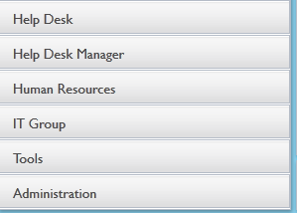

Think of Modules as folders that group your applications. This is a helpful way of keeping similar tasks together as well as granting access to your apps. Below your “Hello kitty” logo is a list of modules which can include;

* Applications
* Time Clock
* Management
* Help Desk
* Help Desk Manager
* Human Resources
* IT Group
* Tools
* Administration
* Help

##### Processes:



Processes are the applications that will help run your business. Under each module there are different buttons (processes) that pertain to that specific module. Only modules and processes you have been granted access to will appear in your workspace.

They can consist of:

* applications like Time Clock, Calendars, To Do List, CDR Mail, etc.;
* existing web applications;
* custom Tables;

You will also find Simple’s tools to manage and customize your application, or grant user access.

##### Work Area:

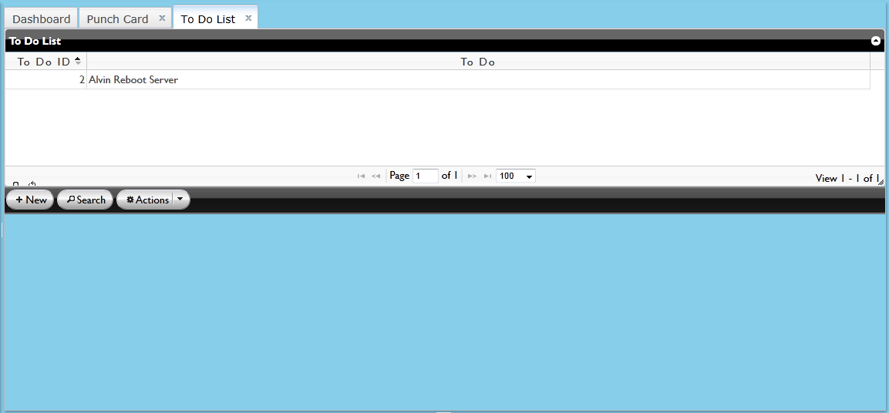

The work area of the application is where active processes will be running. You may identify the active process of your choice in order to get specific information by looking at the grid.

##### Tabs



If you select the process titled “To Do List”, a tab will open in your workspace. On the right there will be two tabs open. The first tab will read “Dashboard”; Next to it you will see any other processes you have opened. The “To Do List” tab will be bold because it is the active process.

Tabs give you quick access to switch tasks without losing any data.

The page is never reloaded!

You can switch back and forth just like a desktop application.

###### Multi-tasking online through Simple Software gives you an edge that most online applications can’t provide.

##### Status Bar



The status bar provides information such as:

* system status
* add, delete, update, relate to records
* person that is currently logged in

It also allows you to change your password. We suggest you change your password now…

##### Change Password



Locate the ‘gear’ symbol and click on it in order to change your password.

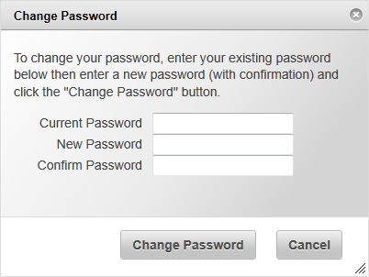

All passwords are database encrypted so they cannot be retrieved!

##### Logout



After you change your password, log out and then log back in.

Section 2: Working With Data & Forms



You go to the “Administration” module and click on App manager to organize your module app and process’s app,

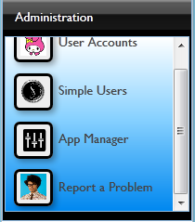

4.) a…For example the screen shot below; See the two applications aka “buttons” below. One has the application titled” Timecards” . And the second application is titled, “To Do List” . Here are great examples of two different “process’s” which are the different applications catered to Sanrio and its workers needs.



If you select “To Do List” a tab will open up to the right that will say “To Do List” next to the “Dashboard” tab. In the open tab you will see inside the white text box to the left of that text box you will see a list of “To Do ID” numbers, then to the right of that a description pertaining to that “To Do ID” number.

(or To-do list next to the dashboard tab. In the open tab you will see a grid of your to-do’s. If you select a to-do, a form will appear below which will show you the detail of your to-do and allow you to perform edits to your to-do such as; change its status, add notes, assign the assignment (to-do) to someone else ect…)

Towards the bottom of the “To Do List” tab there are three buttons that have three different functions;

1st button: +New

Function: You click the [+New] button to create a new “To-Do” whether it’s for that day or for that week.

2nd button: “Search”

3rd button: “Actions”

The screen shot below is of the Sanrio “Help Desk modules” and processes

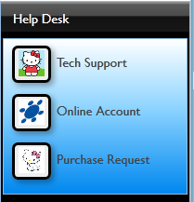

This screen shot below is of the Sanrio “Help Desk” specifics

1. There is a button that can provide any Sanrio employee with “Tech support”
2. There is also Sanrio employee “online account request” assistance.
3. The last button you can click is if you would like to make an “online purchase request”.

The screen shot below is an example of “Technical Support Request”.

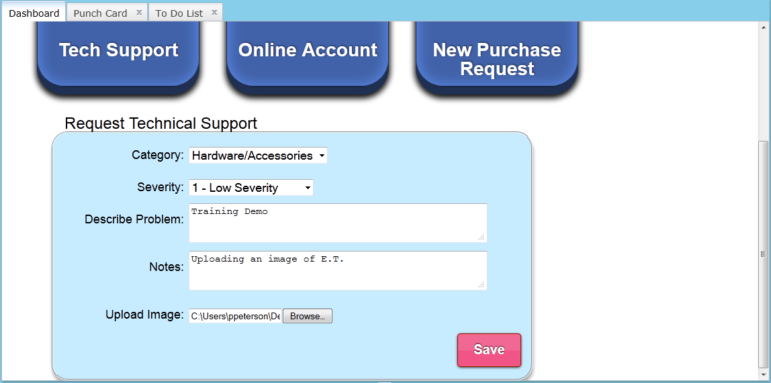

The screen shot below is an example of a “customer online request”

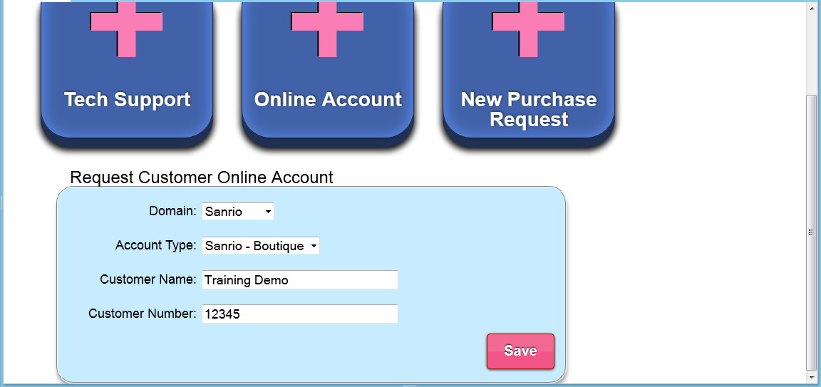

The screen shot below is an example of “ a new purchase request”

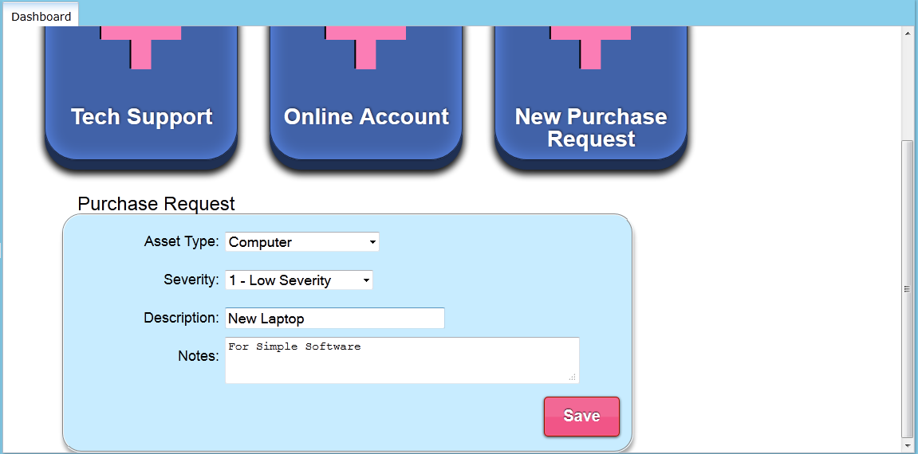

This screen shot is an example of “Forms and Data”.

To elaborate more on the screen shot that you are looking at below…

On the left of the text box you will see “Help desk id”

-Help desk id basically is an id given by the software to help organize and keep track of every form created and to keep track of any data.

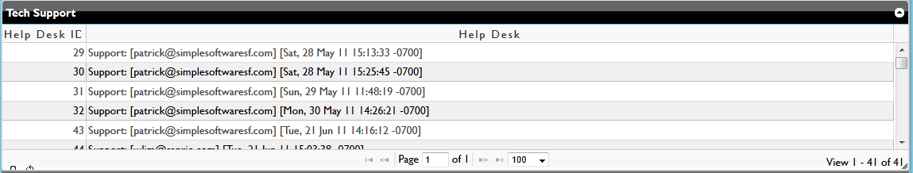

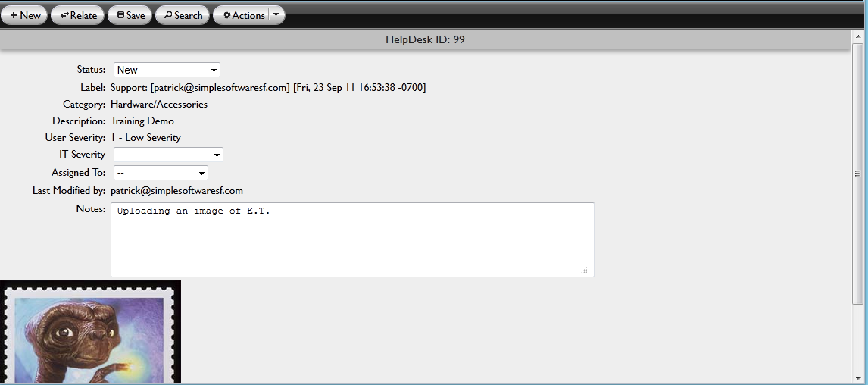

Below is an example of the various buttons that are available on most forms.

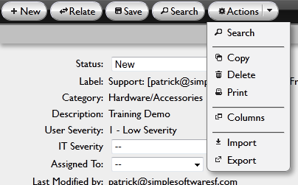

By selecting the ‘Columns’ button, a ‘Column Chooser’ dialogue box appears which allows you to select the items that are displayed in the grid.

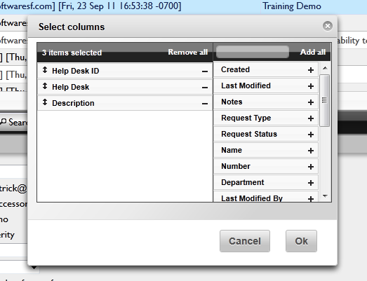

By selecting the ‘Relate’ button, a ‘Relate Data’ dialogue box appears which allows you to relate the selected record to any other data you have permission to access. This is a powerful tool which allows you to convert data and relate it into information with context

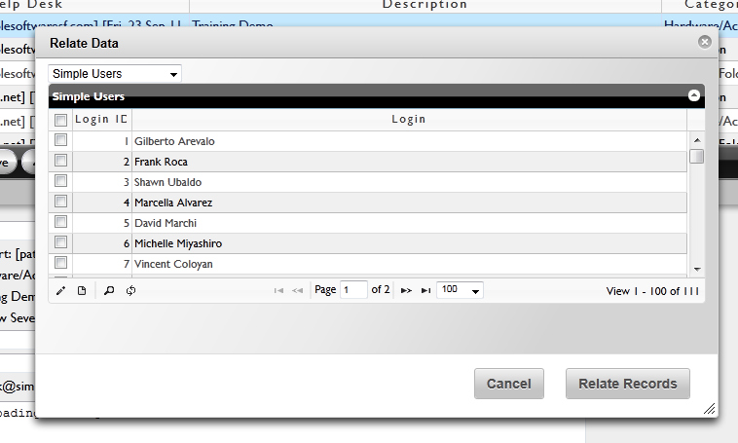

Below the buttons described in previous screen shots above under the e.t picture you will see a few text boxes with the titles “Login id”, “login”, “password”, “first name”, “last name” and “unlink” which helps you?....

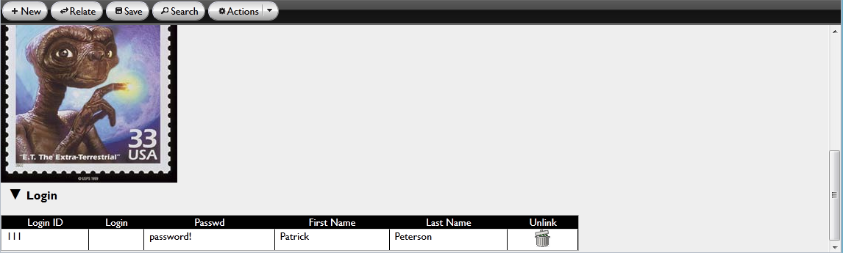

The screen shot below is an example of an e-mail notification with your helpdesk request with updates.

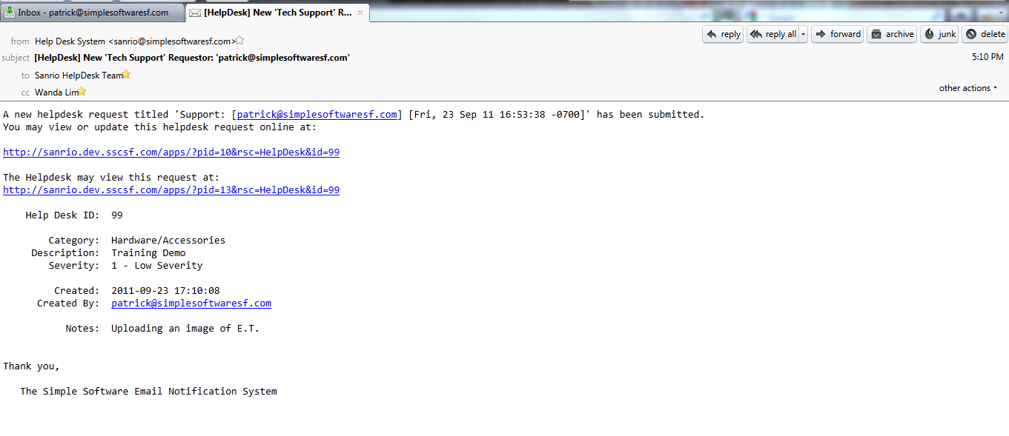

Here is an example of a module with the title “tools” and the various “buttons (applications) below that relate to it. Advanced tools

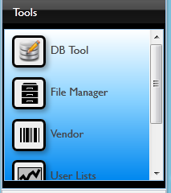

Here’s am example of the DB tool and how you access it to better organize your “Tables and columns”

DB tool

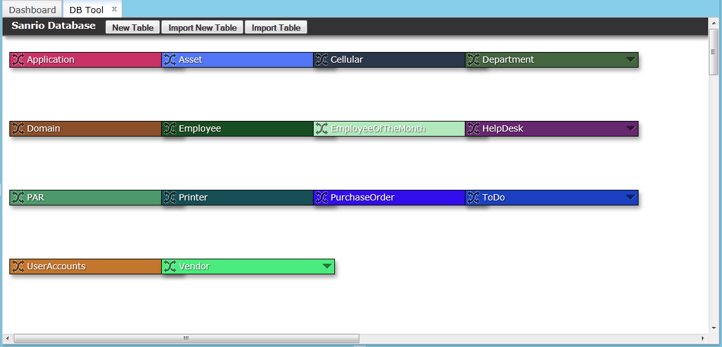

All information you store in a Simple Software application is done with the help of data stores. These data stores, which may also be referred to as ‘tables’, ‘lists’, or ‘catalogs’, are used for storing information of a specific type such as a Client, Activity or Task. The application can be as small as a single store or can have many hundreds of tables. Individual items in a data store are called records.

Each data item or record is comprised of fields which represent specific attributes of the data. For example, a contact is generally represented with a first and last name, an address, phones numbers, e-mails etc. Each of these labels in a Simple Software data store would be a columns

DB tool new table

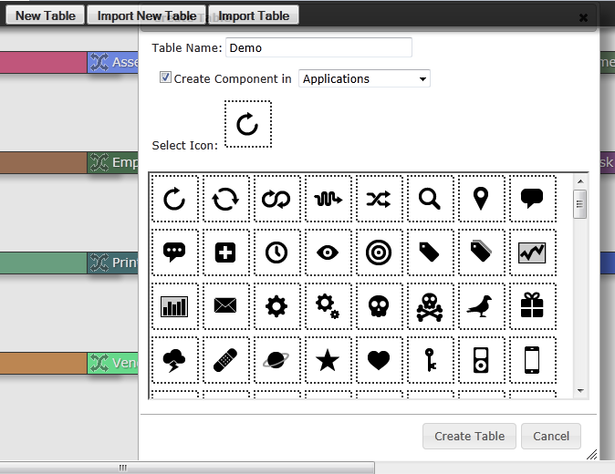

DB tool new column

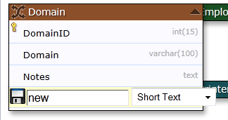

This helps you better manage your site

Application Manager gives you the ability to manage your application through our advanced Module and Process Editor. Our framework is comprised of Modules and Processes. Modules contain Processes…simple.

An example of this may be to create a Module called Sales, and inside of the Module you can create a process called Orders. This Orders process will point to an ‘Orders’ table and Bam!, Bob’s your uncle. Give access to your sales force and the next time they log in, they will see their new order entry system.

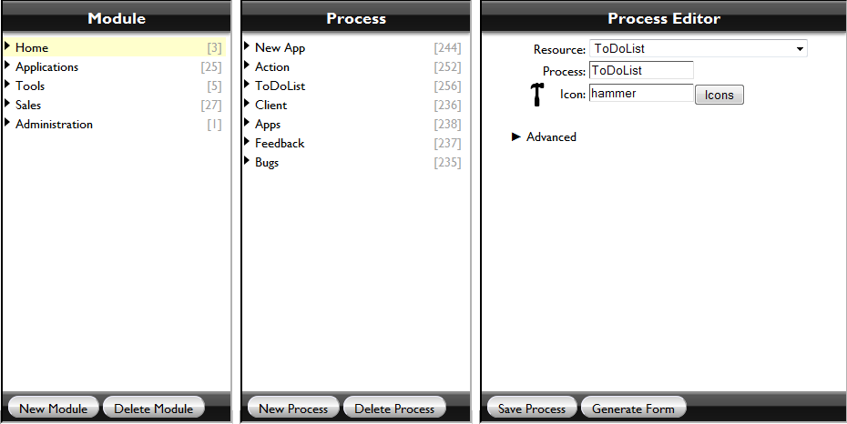

or

Process editor

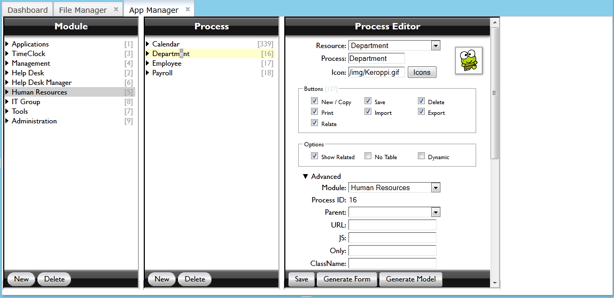

This is an Admin app manager module editor

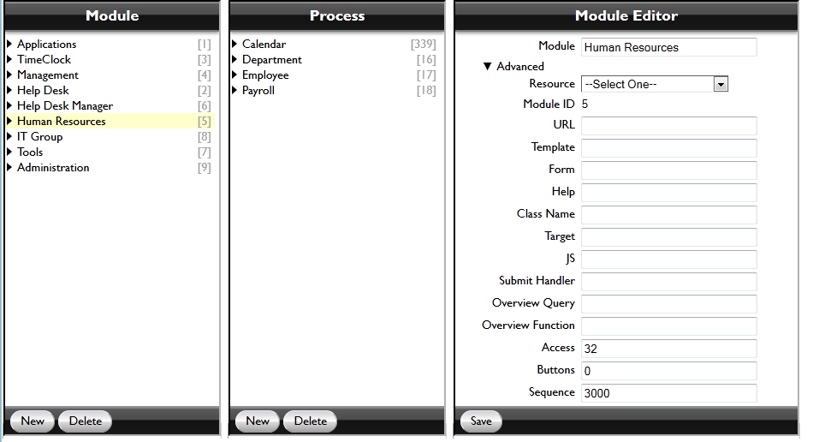

This is an app manager process editor..A process is …

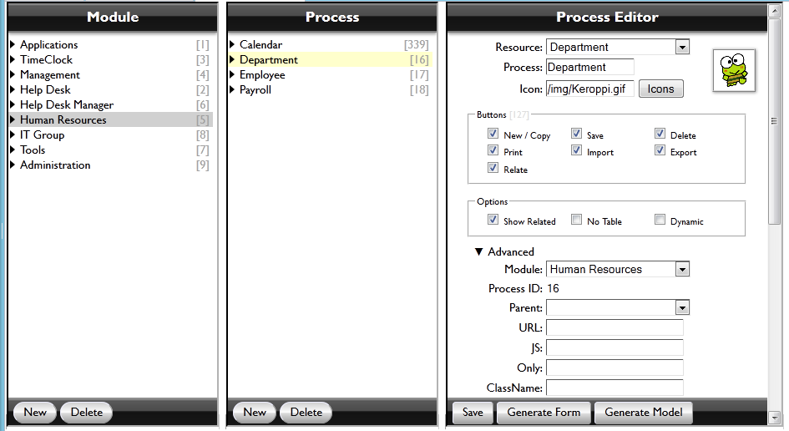

Application and software restrictions

Simple Software uses a concept of role-based security.

A role is a set of security settings applied to every object, such as table records, columns, views and overview pages in Simple Software. Each Simple Software user assigned with the role that determines the representation of the data and the operations available.

Security settings for the table define the set of records the user allowed to see, modify and delete. A column security defines whether the column is visible or editable. It’s the most effective way to restrict the user from accessing sensitive information as views and forms respect these settings in addition to their own access rights.

With view’s security settings you may control the list of views available for each role. And when clicking the tab or viewing or editing the data, the user is presented with a page or form according to defined access rights.

FILE MANAGER

## Content Management/File Share

File Manager gives you the ability to manage your content as well as the visual look of your app. Simple’s framework will search your ‘img’ and ‘templates’ directories before defaulting to our system directories. We also maintain version control in case you need to rollback an app.

‘img’ directory – logo.png is displayed in the upper left hand corner for all users. Upload your company logo or new icons to customize your site.

‘templates’ directory – forms will be automatically created using App Manager and stored here. You may have a need to make changes to existing forms or upload your own. If you want to revert to a previous version, simply download the version you want and then upload it again.

File manager

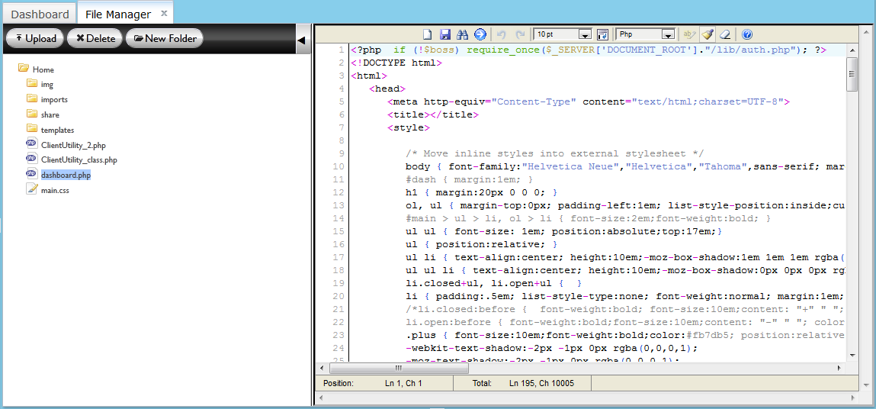

File manger script up close

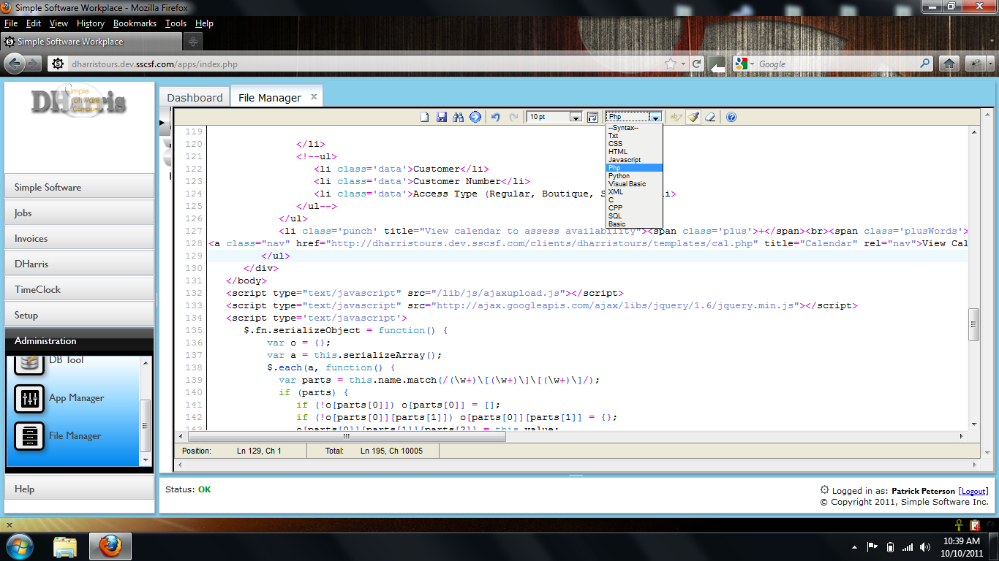

File manager intro

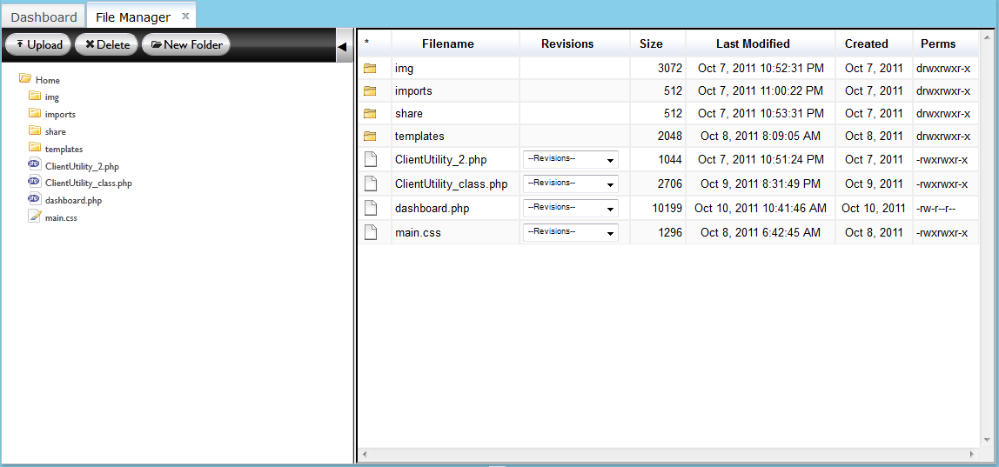

File manager folder tree

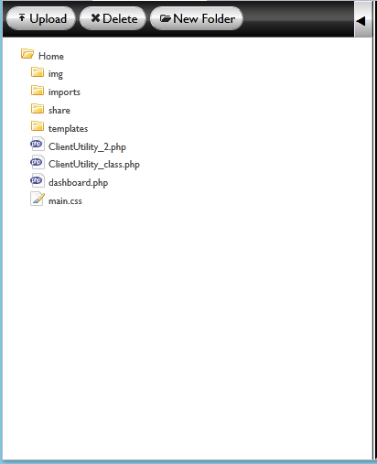

File manager : Detail Pane

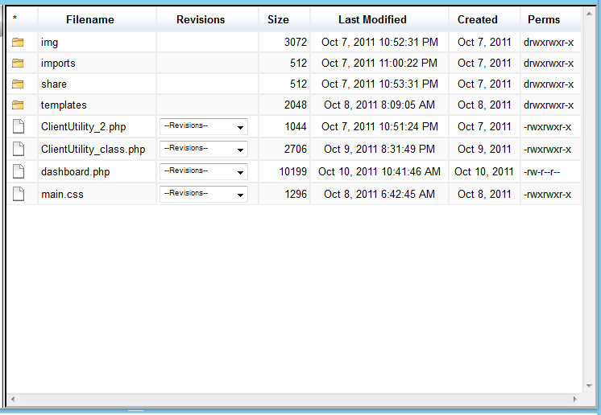

App manager overview query

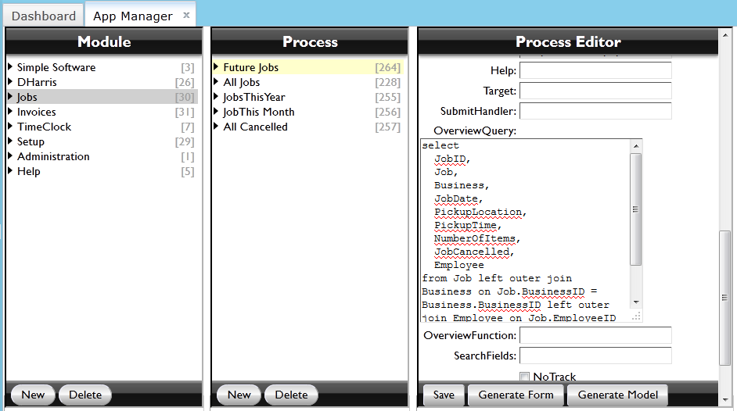

App management restricted grid

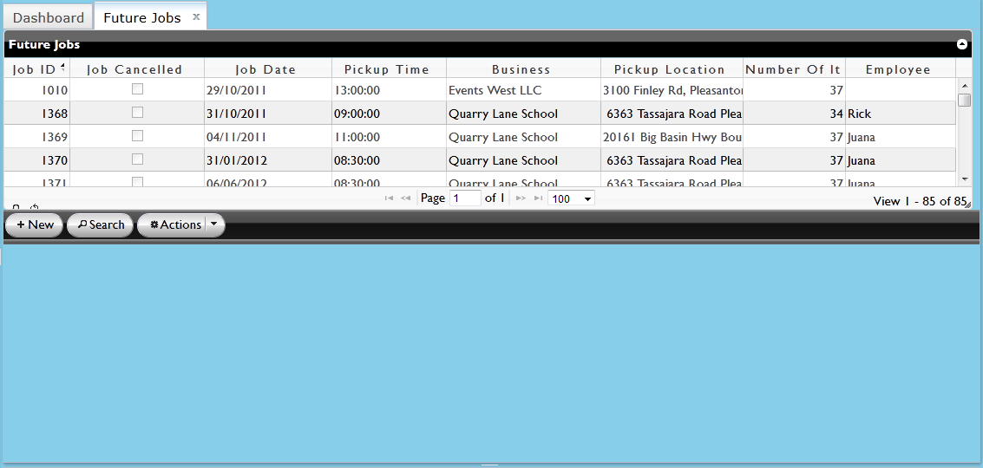

App managment search criteria

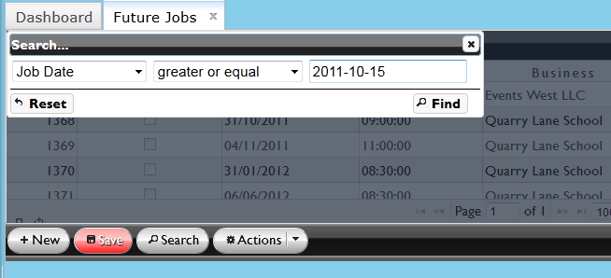

App manager Exporting data subset

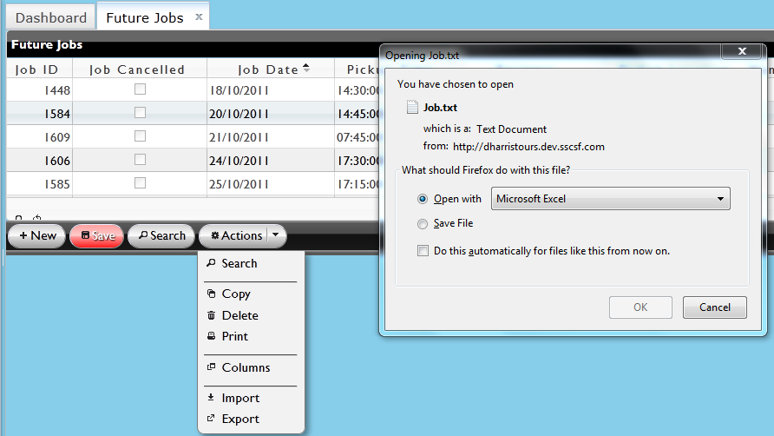

Export data

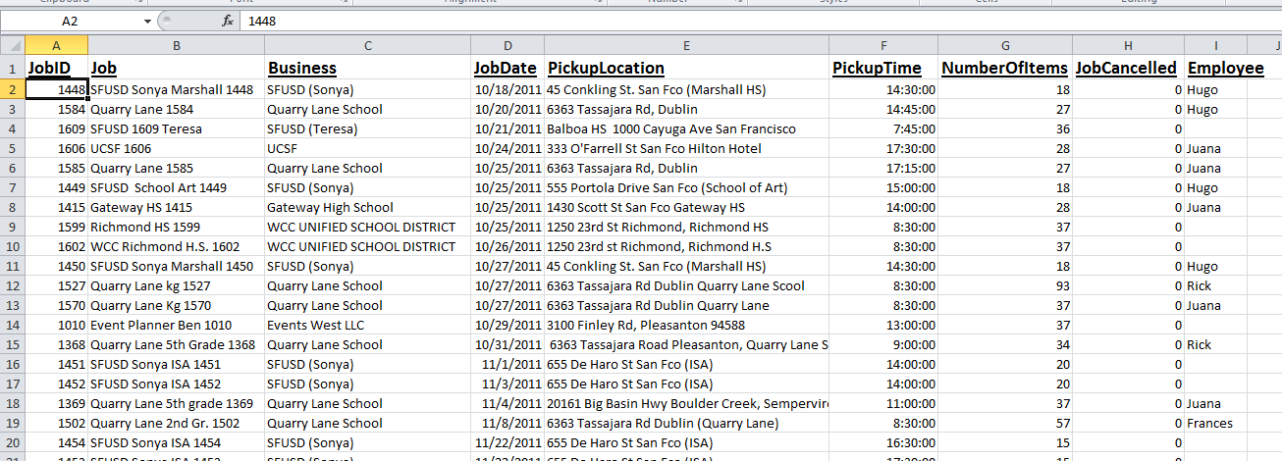

Importing data from TAB file

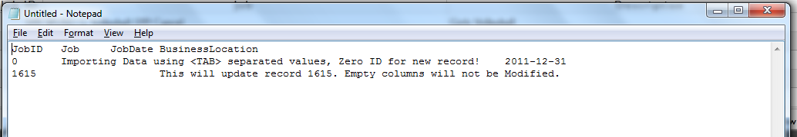

The box below is a screen shot of what you would do if you were going to “Import Data”. As you see there are two tabs open below;

1.) The “Dashboard”

2.) “All Jobs”~When looking at this open tab you can see to the left of the grid the column with the title “Job ID”, the “job” and “Description”. Now below the grid you see many buttons with various actions. The picture below is an example of the “Action” button and specifically how to import data using this button. By selecting “Import” a pop up will appear where you can browse through your computer and upload a ny file.

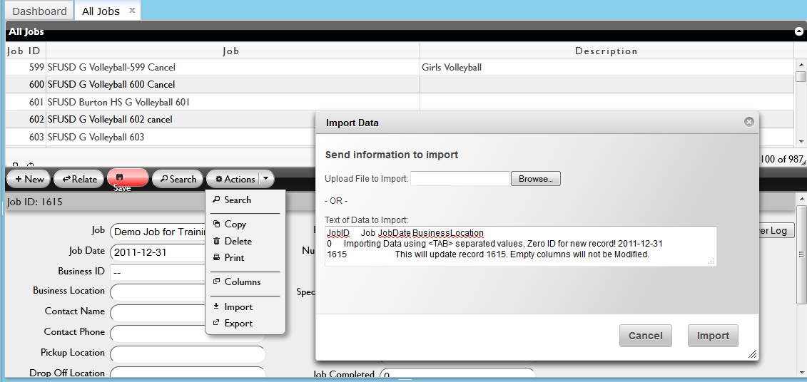

Importing data up-close view of the “Actions” button and its “import” application.

[importing data overview

Applications gallery—can discuss or summarize more than one app.

Now for most employees all they would have to do is clock in and clock out using the “Time Clock” application. As you see in the picture down below there is a Time Clock tab open with a icon of a Time Clock and a mini view of the calendar week. The Time Clock tab will also show you the current time and hours you have worked.

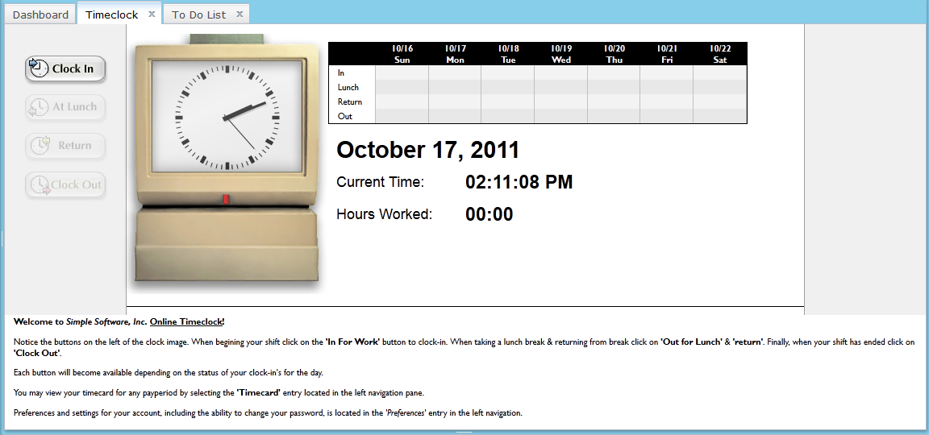  
The Timeclock application was developed by our team of programmers to serve the necessities by Human Resources staff to track all the hourly employee payroll. From this need the Timeclock was developed.